YE4C Editorial Board Cohort 5 Promotional Toolkit

The Youth Engaged 4 Change (YE4C) platform is an extension of the federal Interagency Working Group on Youth Programs’ youth.gov platform and is a space for young people to lead.
YE4C strives to provide resources and opportunities that inspire and empower young people to make a difference in their lives and in the world around them by improving their knowledge and leadership skills.
In February 2020, YE4C launched its Editorial Board, comprised of young people seeking to elevate youth voices on issues that matter to them and their peers. Each year, the Editorial Board continues to evolve with input from past members to ensure a dynamic experience. Since it started, dozens of young people have actively engaged with YE4C and each other to be positive agents of change!

The YE4C Editorial Board connects young people with mentors and creates lasting connections. The group is structured to accommodate geographical diversity, giving members the opportunity to learn how to collaborate effectively across time zones using different communication methods (like email, Zoom meetings, and messaging). Joining the board gives youth and young adults the opportunity to create meaningful content, refine leadership skills, and collaborate with the federal Interagency Working Group on Youth Programs (the Working Group).

We are excited to be recruiting our FIFTH cohort!
Help us spread the word!

YE4C has prepared this promotional toolkit to make it easier for you, your colleagues, and young people to share and support YE4C’s recruitment activities for this unique opportunity. Below you will find social media templates for both youth and adult audiences (with images, alt text, and caption copy), newsletter templates for both youth and adult audiences, and a brief announcement template.

What You Need to Know
YE4C is seeking passionate young people between the ages of 16 and 24 who are eager to expand their knowledge and empower their peers and can commit at least 20 hours per month to apply for this virtual, paid opportunity. The 12-18-month journey starts in March 2024. Meetings are currently planned for the second and fourth Thursday of each month from 7:00 pm ET to 8:30 pm ET (if necessary, meeting times will be changed to meet the needs of the board). The application will be available until February 4, 2024 (11:59 pm PT).
How You Can Help
- Interact with YE4C’s or youth.gov’s existing posts by clicking reactions, commenting, or sharing any of our published social media posts or forwarding the emails you receive from us:

- YE4C Instagram (Youth-Facing Audience) @youthengaged4change

- youth.gov Facebook (Adult-Facing Audience)
@youthdotgov
- youth.gov LinkedIn (Adult-Facing Audience)
@youth-gov

- youth.gov X (Adult-Facing Audience)
@youthdotgov

- Activate your own communication channels by posting any of the promotional materials we provide below.

Social Media Templates
To download the social media images, we recommend visiting the promotional toolkit on YE4C, right-clicking on images, and saving them to your desired drive.

For Youth Audiences:

Images for Youth Audiences:
Square images — ideal for Instagram posts
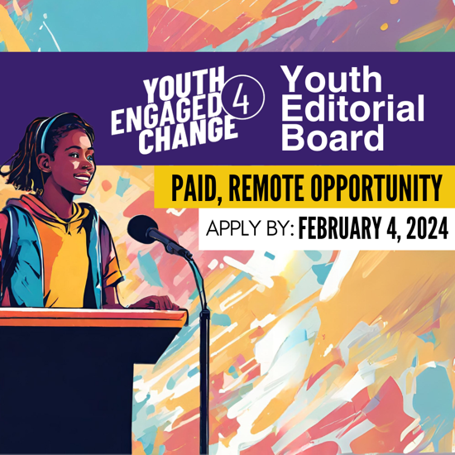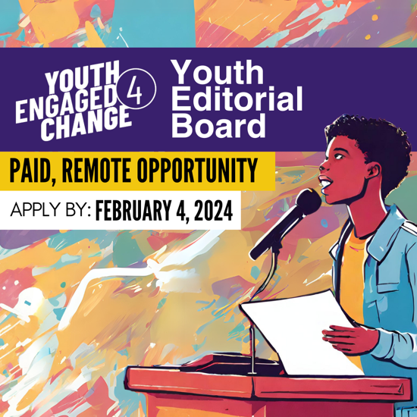

Landscape/horizontal images — ideal for X/Facebook/LinkedIn posts
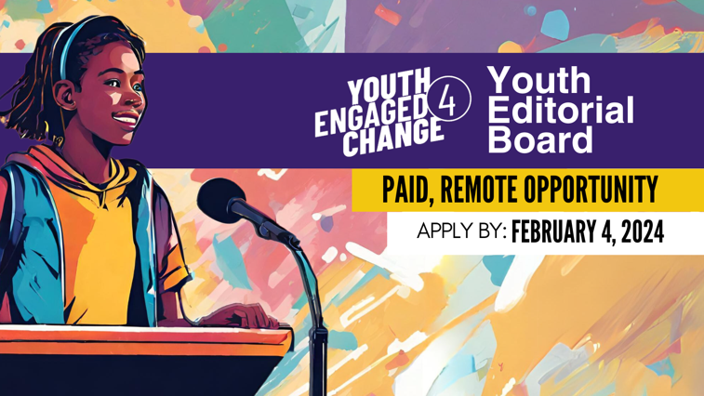
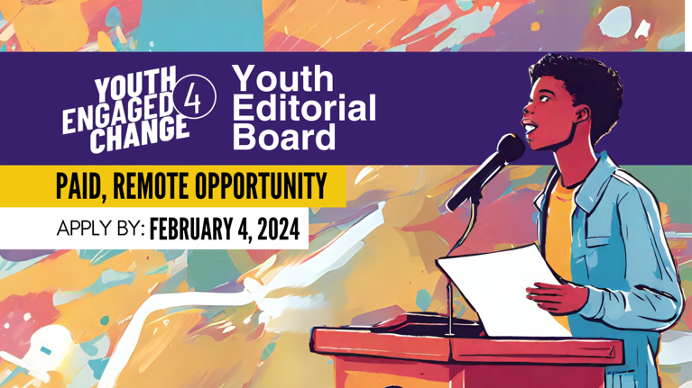
Portrait/vertical images — ideal for Instagram/Facebook stories and Snapchat posts
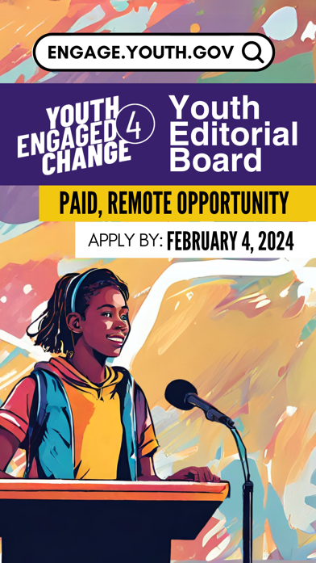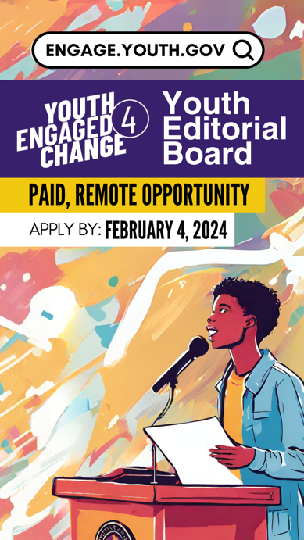

Alt Text for Images for Youth Audiences:
(Please note: The same alt text applies to all the images for youth audiences above.)
Colorful illustration of a young person speaking at a podium. Text overlay reads YE4C Youth Editorial Board. Paid, Remote Opportunity. Apply by February 4, 2024. Youth Engaged 4 Change logo.

Caption Copy for Youth Audiences:
- Get ready to make your mark! 🚀 @youthengaged4change is now recruiting new Editorial Board members. This paid, remote opportunity is a chance for YOU to be a dynamic voice for change. Apply by February 4! 📢 https://engage.youth.gov/blog/use-your-voice-change-ye4c-editorial-board
#YouthEmpowerment #Changemakers #Opportunity #Leadership #YE4C

- Let your voice be the catalyst for change! 🌎 The @youthengaged4change Editorial Board is the place to be – where ideas take flight, connections flourish, and empowerment is the key. 🤝 Applications are due February 4! https://engage.youth.gov/blog/use-your-voice-change-ye4c-editorial-board
#YouthEmpowerment #Changemakers #Opportunity #Leadership #YE4C

For Adult Audiences:

Images for Adult Audiences:
Square image — ideal for Instagram posts
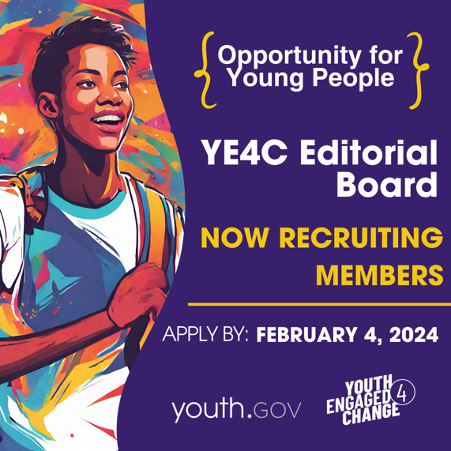

Landscape/horizontal image — ideal for X/Facebook/LinkedIn posts
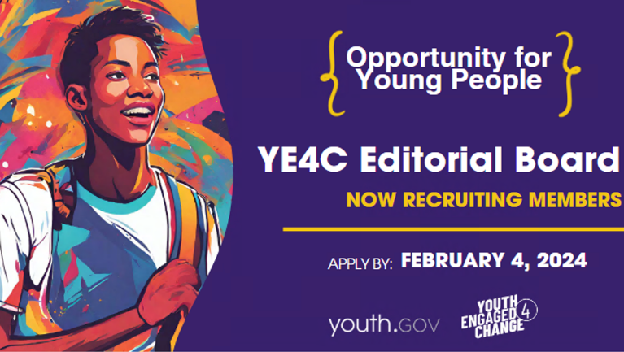
Portrait/vertical image — ideal for Instagram/Facebook stories and Snapchat posts
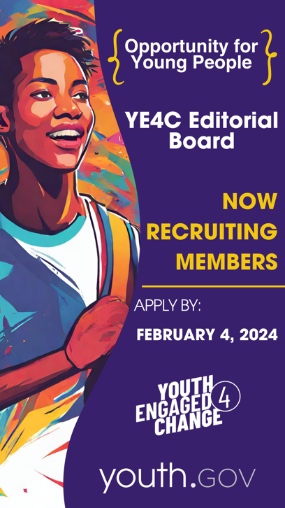

Alt Text for Images for Adult Audiences:
(Please note: The same alt text applies to all the images for adult audiences above.)
Colorful illustration of a young person with a cross-body bag beside a solid purple background. Text overlay reads Opportunity for Young People. YE4C Editorial Board. Now Recruiting Members. Apply by February 4, 2024. youth.gov logo. Youth Engaged 4 Change logo.

Caption Copy for Adult Audiences:
- Spread the word! Encourage the young people you know (ages 16-24) to apply for a virtual, paid position on the YE4C Editorial Board. This opportunity involves creating content to educate and inspire other young people to be leaders and changemakers in their communities. Applications are open until February 4! #YouthEmpowerment #Changemakers #Opportunity #Leadership #YE4C https://engage.youth.gov/blog/use-your-voice-change-ye4c-editorial-board
Shortened Caption — ideal for X (Formerly Twitter)
Encourage young people ages 16-24 to apply for a virtual, paid position on @youthdotgov’s YE4C Editorial Board! This opportunity involves creating content to educate and inspire other young adults to be leaders and changemakers in their communities. Learn more: https://engage.youth.gov/blog/use-your-voice-change-ye4c-editorial-board

- Share with youth: YE4C is looking for young people ages 16-24 to join the YE4C Editorial Board! Members will develop meaningful and engaging content for the YE4C website and social media in this remote, paid opportunity. We invite #youth and young adults to apply by February 4, 2024! #YouthEmpowerment #Changemakers #Opportunity #Leadership #YE4C https://engage.youth.gov/blog/use-your-voice-change-ye4c-editorial-board

Shortened Caption — ideal for X (Formerly Twitter)
Share w/youth: @youthdotgov’s YE4C is looking for youth and young adults ages 16-24 to join the YE4C Editorial Board! Members will develop meaningful and engaging content for the YE4C website and social media in this remote, paid opportunity. We invite #youth to apply by February 4, 2024! https://engage.youth.gov/blog/use-your-voice-change-ye4c-editorial-board

Newsletter/Email Templates

Email for Youth Audiences:
Subject Line:
Hey young changemakers! Are you ready to bring your voice to the forefront and amplify the voices of other young people?

Body Copy:
Youth Engaged 4 Change (YE4C) is seeking candidates ages 16-24 for its Editorial Board to help shape strategy and content that truly matters to you and your peers. This virtual, paid opportunity connects you with other changemakers and federal staff who are doing interesting work, fostering lasting connections. The group is structured to accommodate geographical diversity, giving members the opportunity to learn how to collaborate effectively across time zones using different communication methods (like email, Zoom meetings, and messaging).

YE4C is an extension of youth.gov and is a space for young people to lead. YE4C’s mission is to provide resources and opportunities that inspire and empower young people to make a difference in their lives and in the world around them by improving their knowledge and leadership skills.

If you or someone you know are between the ages of 16 and 24, prepared to commit at least 20 hours per month, and passionate about empowering fellow young people, apply now! The 12-18-month journey awaits, beginning in March 2024. Meetings are currently planned for the second and fourth Thursday of each month from 7:00 pm ET to 8:30 pm ET (if necessary, meeting times will be changed to meet the needs of the board).

We invite young people ages 16-24 to apply by February 4, 2024 (11:59 pm PT), to the YE4C Editorial Board and help shape strategy and content that truly matters to youth and young adults.

For more information and how to apply, visit the YE4C website.

Email for Adult Audiences:
Subject Line:
Know a young changemaker? YE4C is seeking Editorial Board applicants. Help us spread the word!

Body Copy:
Youth Engaged 4 Change (YE4C) seeks candidates ages 16-24 for the fifth cohort of its Editorial Board. Would you be willing to lend a hand in spreading the word about this amazing opportunity to passionate young people? Your help could make a difference in connecting enthusiastic individuals to life-changing opportunities.

YE4C is an extension of youth.gov and is a space for young people to lead. YE4C’s mission is to provide resources and opportunities that inspire and empower young people to make a difference in their lives and in the world around them by improving their knowledge and leadership skills.

The YE4C Editorial Board helps shape strategy and content that truly matters for diverse young people. This 12-18-month virtual, paid opportunity fosters lasting connections between young changemakers and federal staff doing interesting work, fostering lasting connections. The group is structured to accommodate geographical diversity, giving members the opportunity to learn how to collaborate effectively across time zones using different communication methods (like email, Zoom meetings, and messaging).

If someone you know is between the ages of 16 and 24, prepared to commit at least 20 hours per month, and is passionate about empowering fellow young people, please invite them to learn more on the YE4C website, where the application will be live from January 17 to February 4 (11:59 pm PT).

Brief Announcement Template
Youth Engaged 4 Change (YE4C) seeks passionate young people to apply to join the 5th cohort of the YE4C Editorial Board! YE4C is an extension of youth.gov and is a space for young people to lead. YE4C’s mission is to provide resources and opportunities that inspire and empower young people to make a difference in their lives and in the world around them by improving their knowledge and leadership skills.

The Editorial Board gives youth and young adults between the ages of 16 and 24 the opportunity to create meaningful content, strengthen leadership skills, collaborate with the Interagency Working Group on Youth Programs, and be an ambassador to peers.

To learn more about this amazing 12-18-month virtual, paid opportunity, visit the YE4C website.

